A Novel IoT and AI-Driven Infectious Disease Outbreak Detection System

Devraj K Chandani¹, Shaurya Saini², Pooja Goel³, Syamasudha Veeragandham⁴
^{1,2,3,4}Vellore Institute of Technology-Vellore, Tamil Nadu, India-632014
⁴Corresponding Author: Syamasudha Veeragandham
Email: ¹devraj.kchandani2023@vitstudent.ac.in, ²shaurya.saini2023@vitstudent.ac.in, ³pooja.goel2023@vitstudent.ac.in, ⁴ syamasudha.v@vit.ac.in

ABSTRACT
Early infectious disease outbreak detection, especially in areas with limited resources is difficult, mainly due to the delays in lab confirmation and reporting. In this paper we propose a novel real time IoT and AI surveillance framework named EpiSense that combines real-time environmental sensor data with anonymized patient symptom trends to provide proactive early warnings about outbreaks. Low cost IoT devices continuously monitor environmental parameters including water turbidity, total dissolved solids, water pH level, temperature, and humidity parameters known to influence the spread of waterborne and vector-borne diseases. Simultaneously, symptoms data from clinics such as fever, diarrhea, rash, and respiratory complaints are anonymously collected via web interfaces and APIs. The inputs are then processed by a machine learning pipeline using a Random Forests classifier which assesses environmental contamination probability, while a time decayed weighted score quantifies symptom severity. The two scores are combined into a single Outbreak Risk Index (ORI) using adjustable weights derived through cross-validation. Based on the predefined thresholds on the Outbreak Risk Index, the system then generates 3-tiered alerts – Advisory, Warning and Critical. A retrieval augmented generation module then matches current patterns to a database of historical outbreak reports, enabling the system to produce impactful preventive measures. The system was trained and tested on both synthetic outbreak simulations using stochastic Susceptible, Infective, Recovered (SIR) models and real historical surveillance data. It achieved over 0.97 AUC in detecting outbreaks and provided alerts 5 to 7 days before reports. Our results demonstrate that integrating IoT environmental sensing with clinical symptom analytics and historical knowledge retrieval can improve responsiveness to infectious disease outbreaks especially in low resource settings through early alerts and by providing preventive measures.

Keywords: IoT, Infectious Disease Surveillance, Random Forests, LSTM, Retrieval-Augmented Generation, Outbreak Risk Index, Syndromic Surveillance, Waterborne Diseases, Vector-Borne Diseases, Early Warning Systems, Public Health Informatics.

INTRODUCTION
Infectious disease outbreaks are a concern for public health especially in rural areas with limited resources. Diseases like Hepatitis A and E, cholera, typhoid fever, malaria, and dengue fever continue to exist in tropical regions, particularly in areas where there is poor sanitation, stagnant water, and limited healthcare infrastructure. The current methods for outbreak detection are reactive rely on lab diagnosis and manual reporting, causing a significant time delay between when an infectious disease outbreak actually occurs and when it is officially identified and preventive measures are taken. This delay leads to further spread of the outbreak leading to avoidable deaths and illness. Environmental factors directly impact infectious disease epidemiology. Water sources, stagnation of water, water contamination, temperature, and humidity directly influence how waterborne and vector-borne diseases spread [1]. These factors are well established indicators of disease outbreaks, yet despite their importance, traditional surveillance systems fail to monitor them.
Currently, healthcare facilities do observe trends in symptoms from patients, however this data is usually distributed across different healthcare facilities. In smaller or rural clinics, the digital infrastructure required to collect this symptom data for analysis is not present. Even where such infrastructure exists, the symptom data is never combined with environmental data, leading to less impactful preventive measures and less reliable detection. Combining modern standards of Internet of Things and artificial intelligence and machine learning we can achieve a reliable and scalable solution to overcome these limitations. IoT sensors continuously monitor environmental parameters like water contamination levels at the community level [1]. Combined with patient symptom data, these data sources provide a real time picture of potential disease outbreaks that no single source of data can provide.
IoT technology has become a significant enabler for public health surveillance, but low-resource areas are yet to fully benefit from its capabilities. In their 2021 study, Sahu and colleagues assessed next-generation IoT-enabled public health surveillance architectures. The results indicated that real time environmental data streams, often high frequency and high volume, can be generated continuously at modest cost using basic sensors and microcontroller platforms [2]. Also, their analysis reveals that while IoT deployments like water quality monitoring, air pollution tracking, and vector surveillance have each advanced in isolation, their existing implementations still remain operationally disconnected. Importantly, Sahu et al. also identified that the absence of interoperability between environmental sensing networks and frontline healthcare systems is one of the primary obstacles to realizing the potential of IoT in early disease outbreak detection. This gap still persists even though there is clear evidence correlating environmental degradation with disease outbreaks.
In addition to this, recent advances in machine learning applied to environmental monitoring have shown that contamination levels can be predicted with high reliability from sensor data alone. Nemade et al. (2024) built an IoT‑based water quality monitoring system that uses turbidity, total dissolved solids, pH level and temperature sensors with an XGBoost classification pipeline. In deployed conditions, their system achieved around 98% accuracy in predicting water contamination levels [3]. The system developed by Nemade and colleagues, still only remained exclusively focused on water quality prediction. It did not incorporate any clinical symptom data from real patients. At the same time, while their classifier could identify when water sources became contaminated, it could not determine whether the contamination resulted in disease outbreaks. This distinction severely restricts the utility of such systems for early outbreak detection. EpiSense is our response to this gap. We propose a unified surveillance system that connects arrays of low cost IoT sensor deployed near various water sources with anonymized symptom reports submitted through community healthcare systems, and processes both through a AI pipeline comprising a Random Forests environmental classifier, an LSTM based temporal risk model, and a retrieval augmented generation module for contextual alerting and preventive measures. The system is designed not as a research prototype but as a practically deployable tool for low resource areas, built around low hardware cost and data privacy. By generating automated, tiered Outbreak Risk Index alerts days before lab confirmed case counts would trigger traditional surveillance responses, EpiSense shifts public health practice from being reactive to proactive, creating a critical window for timely interventions that can meaningfully prevent outbreaks from further increasing.

Objectives

EpiSense is designed around five core objectives that collectively define its novelty and practical contribution:
- To design and deploy a low cost, solar-powered IoT sensor network capable of continuous real-time environmental monitoring covering water turbidity, TDS, temperature, and humidity in field conditions typical of LMIC rural communities, at a per-node hardware cost under INR 2,500.
- To develop an XGBoost-based environmental contamination classifier that derives a probabilistic E-score from multi parameter sensor data, and a time decayed syndromic burden score (S-score) that captures the recency-weighted clinical load at each community zone.
- To formalize a unified Outbreak Risk Index (ORI) that fuses E score and S score into a single bounded scalar with empirically validated tiered alert thresholds, enabling consistent, interpretable outbreak risk communication to non-technical health officials.
- To build a retrieval-augmented generation module that, at alert time, retrieves the most semantically similar historical outbreak case summaries from a curated document store and uses them to ground GPT-4 advisory generation producing disease-specific, actionable, and citation-backed alert messages that minimize hallucination.
- To validate EpiSense end-to-end on both synthetic SIR epidemic simulations and real-world surveillance data, measuring classification AUC, alert lead time, and false positive rate, and demonstrate performance superior to single-modal baselines through systematic ablation.

LITRATURE REVIEW
Recent developments in disease surveillance shows the increasing potential of the Internet of Things, and machine learning in enhancing outbreak detection and prevention systems. Current surveillance systems are still mostly dependent on lab-confirmed cases, hospital reports, and traditional epidemiological investigations. Though these methods ensure high diagnostic accuracy, they are usually slow and inefficient in early outbreak detection especially in environments with limited resources. These delays in outbreak reports have been identified as one of the main factors that undermine effective outbreak control [1].

IoT Based Environmental Health Surveillance

IoT-based health surveillance is a promising solution for real time environmental monitoring [1]. Liu et al. (2020) conducted a comprehensive survey of IoT based public health monitoring systems, showcasing the importance of edge computation for offline resilience in LMIC environments and also identifying low connectivity and power management as the main deployment challenges [1]. Sahu et al. (2021) also demonstrated that IoT systems can produce high frequency, high volume continuous data streams for real time environment monitoring, but also noted that most current deployments remain restricted within single environmental domains like water contamination or air pollution [2]. Nemade et al. (2024) implemented an IoT based water quality monitoring system integrating sensors like turbidity, TDS, pH and water temperature along with XGBoost based classifier, achieving around 98% accuracy in predicting water contamination levels, providing a foundational basis for the environmental sensing approach adopted in EpiSense [3]. Despite these advances, there is no existing IoT deployment that bridges the gap between environmental sensing and clinical data in a single deployment.

Machine Learning for Outbreak Prediction

Machine learning has demonstrated significant potential in outbreak prediction tasks. Gao et al. (2025) proposed a time series classification framework using 22 statistical and 5 early warning features derived from stochastic SIR simulations, achieving AUC of up to 0.99 on synthetic datasets and demonstrating real world COVID-19 prediction approximately one week before the official recognition [4]. Another study [5] reviewed technological trends in epidemic prediction across 87 published systems, explicitly identifying the combination of environmental IoT data with clinical surveillance as an open and critical research challenge that no existing system had adequately addressed. Inam et al. (2025) conducted a systematic review of machine learning for climate sensitive infectious disease prediction, finding that CNN-LSTM hybrid architectures and gradient boosting models significantly outperform traditional statistical approaches particularly when temporal dependencies and mixed data types are involved [6]. Zhu et al. (2025) published a spatiotemporal dataset of dengue fever risk factors across all Brazilian municipalities from 2001 to 2024, providing the only publicly available large scale real world benchmark for environmental disease surveillance that is used directly in this work [7].

Retrieval-Augmented Generation in Public Health
Large language models applied to health advisory generation carry significant hallucination risk, which makes retrieval-augmented generation a critical architectural choice for clinical deployment. Huang et al. (2025) demonstrated that adding a retrieval component to a GPT-4 pipeline raised COVID-19 claim verification accuracy from 0.856 to 0.981 a 14.6 percentage point improvement attributable solely to grounding LLM generation in retrieved verified documents [8]. Xu et al. (2025) introduced MEGA RAG, a multi-evidence retrieval framework for health question answering that aggregates evidence from heterogeneous source types including clinical guidelines, PubMed abstracts, and WHO situation reports, achieving F1 approximately 0.79 on health QA benchmarks [9]. Lewis et al. (2020) established the foundational architecture of RAG for knowledge-intensive NLP tasks, demonstrating that retrieval-augmented models significantly outperform parametric-only models on factual accuracy [10]. Rama et
al. (2025) also identified the absence of a unified, privacy aware outbreak surveillance platform combining real time sensing with contextual AI reasoning as the primary unmet need in early warning systems [11].

Comparison

Despite these advances, no existing system has integrated all three modalities real-time IoT environmental sensing, anonymized clinical syndromic data, and RAG-enhanced contextual alerting into a single validated framework. Table 1 summarizes the positioning of EpiSense relative to all key related works.

Table1. Comparison of EpiSense with all key related works

Study | IoT | Clincal | ML Model | RAG | Real  Time | Real Data  Validated
Liu et al. (2020)[1] | Yes | No | Survey only | No | Partial | No
Sahu et al. (2021)[2] | Yes | Partial | None | No | Partial | No
Nemade et al.(2024) [3] | Yes | No | XGBoost | No | Yes | Yes
Gao et al. (2025)[4] | No | Synthetic  only | GBM/SVM | No | No | Partial
Kamarul  et al. (2025)[5] | Review | Review | Review | No | N/A | N/A
Inam et al. (2025)  [6] | No | Review | Review | No | N/A | N/A
Zhu et al. (2025)  [7] | No | No | Dataset only | No | No | Yes
Huang et al. (2025)  [8] | No | No | GPT-4+RAG | Yes | No | No
Xu et al. (2025)  [9] | No | No | MEGA-RAG | Yes | No | No

Scope of Problem

EpiSense is scoped specifically for rural and semi urban communities in low resource tropical settings where infectious disease outbreaks correlate strongly with measurable environmental degradation contaminated water sources, stagnant water bodies promoting vector breeding, and heat-humidity conditions accelerating pathogen replication. These communities share a common profile: limited or absent laboratory diagnostic infrastructure, delayed or absent formal surveillance reporting, and a high burden of waterborne and vector borne disease.
The four targeted diseases, that is, cholera, typhoid fever, dengue fever, and malaria are among the highest-burden preventable infectious diseases globally. Additionally, these diseases share the defining characteristic that their emergence is predicted by environmental preconditions detectable weeks before reports of clinical cases rise measurably. The Zhu et al. (2025) dengue dataset [7] shows this relationship at across 5,570 municipalities over 23 years, making it an ideal validation dataset for EpiSense.
EpiSense is designed to complement and not replace existing surveillance systems. Its role is to provide a statistically grounded early warning that allows health authorities to regulate resources and implement environmental interventions and preventive measures before disease outbreaks become self-sustaining. All patient data is anonymized at source and the system processes only zone level symptom counts and never handles individual patient identifiers, medical histories, or personal information.

Gaps Addressed

EpiSense is targeted to address four clearly identifiable gaps in the current disease surveillance landscape:
    - Delayed Detection: Reliance on lab confirmed cases only means that by the time an alerts are issued, community transmission is already well established. Gao et al. (2025) showed that even their best ML classifier, when applied to real data, only achieved recognition near the official outbreak date [4] confirming that single-modal clinical or incidence based systems cannot provide meaningful preemptive lead time.
    - Data Isolation: IoT environmental systems and clinical surveillance systems operate in independent silos. As documented by Liu et al. (2020) [1], neither category of system is designed to interact with the other, despite the strong theoretical and empirical basis for environmental-clinical fusion as an early warning strategy.
    - Absence of Contextual AI Reasoning: Standard ML classifiers output a risk score but provide no contextual interpretation no disease hypothesis, no recommended intervention, no connection to what historically happened under similar conditions. Rama et al. (2025) identify this as the primary limitation of current AI based early warning tools [11].
    - Undeployed RAG Potential: Huang et al. [8] demonstrate that RAG dramatically improves LLM factual accuracy in health contexts, yet no existing real-time surveillance system applies RAG to outbreak alerting. This is the most directly exploitable gap that EpiSense fills.

EpiSense directly addresses all four gaps by building the first system that simultaneously fuses IoT environmental data with anonymized clinical syndromic data, applies a hybrid Random Forests and LSTM risk model, and grounds its natural language alerts in RAG retrieved historical outbreak context delivering earlier, richer, and more actionable outbreak warnings and preventions than any prior system.

METHODOLOGY
EpiSense is implemented as a five-layer hybrid IoT and AI pipeline. The layers are: Edge Sensing, Data Ingestion and Preprocessing, Feature Engineering, Risk Inference, and Alerts and Communication. Each layer is designed for lightweight and low power operation to match the deployment realities of LMIC communities.

Data Collection and Sources

IoT sensor kits are deployed near water sources, community standpipes, and weather observation points within each monitored zone. Each kit is built around an ESP32 microcontroller running custom MicroPython firmware. The firmware implements a two-thread architecture: a sampling thread reads all sensors every 60 seconds and appends readings to a circular buffer, while a transmission thread computes a 1-hour rolling average and publishes compressed JSON payloads via HTTP over Wi-Fi
802.11 b/g/n. In zones without Wi-Fi coverage, SIM800L GSM modules will provide GPRS fallback. Nodes are powered by 6,000 mAh LiPo batteries with 6 W solar charging panels, enabling unattended continuous operation. Where connectivity fails entirely, nodes buffer up to 72 hours of readings to onboard flash and transmit in bulk when connectivity is restored. Total hardware cost per node is approximately INR 2,500.
Clinical data is collected through a lightweight web application built for community health workers or APIs integrated with the current existing healthcare systems. Submissions of daily zone level symptom counts across six categories: acute watery diarrhea, fever (axillary temperature above 37.5 degrees Celsius), vomiting, skin rash, severe headache, and acute respiratory symptoms. All submissions are zone tagged and timestamped. No patient names, ages, diagnoses, or any other personal information is entered, collected, or stored at any point in the data pipeline.
Three sources of training data were assembled. First, 2,000 synthetic SIR outbreak trajectories were computationally generated using stochastic SIR parameters drawn from validated epidemiological literature ranges: transmission rate beta drawn from Uniform [0.2, 0.6], recovery rate gamma drawn from Uniform [0.05, 0.15], and population N set to 10,000 per zone. Environmental contamination events were simulated to precede symptom surge by 3 to 10 days, matching the known incubation and lag dynamics of water-based diseases. Gaussian noise at 5% of sensor range was added to all simulated readings to approximate real field variability. Second, the Zhu et al. (2025) Brazil dengue spatiotemporal dataset [7] was used for real world validation, providing labeled outbreak and non-outbreak periods across Brazilian municipalities matched to environmental risk factors. Third, a curated 1,200-sample water quality dataset assembled from published IoT monitoring field studies provided labeled training data for the Random Forests environment score classifier.

Feature Engineering

    - Environmental Score (E-score)
The Environmental Score quantifies the probability that current water quality conditions in a zone present a contamination risk sufficient to drive an outbreak emergence. A Random Forests binary classifier [15] is trained on the curated water quality dataset. The input feature vector includes: current turbidity, TDS, pH level, water temperature, ambient air temperature, relative humidity, and a 24-hour linear trend slope of all of the five parameters. The trend slopes capture whether conditions are worsening or improving, which carries predictive information beyond the instantaneous reading alone. The classifier output the predicted probability of the contaminated class is taken directly as E_score (Environment Score).

Symptom Severity level Score (S-score)
The Symptom severity level Score quantifies the data in clinical reports at each zone with relation to the historical baseline. First the symptom data submitted is normalized by dividing each count by the 30-day rolling zone baseline for that specific symptom category, resulting in a dimensionless multiplier that shows the deviation from normal. The Raw Symptom severity level is then calculated by taking the weighted sum of these normalized counts:
RawSeverityLevel = 0.40·F + 0.35·D + 0.15·V + 0.05·R + 0.05·Res (1)
Here: F = normalized symptom count (fever); D = normalized symptom count (diarrhea); V = normalized symptom count (vomiting); R = normalized symptom count (rash); Res = normalized symptom count (respiratory);
S_score_initial = min (RawSeverityLevel / PopulationZone, 1) (2)
Here: `PopulationZone` = Population size in each symptom report;
`S_score_initial` is basically the min-max normalized `RawSeverityLevel`

Temporal Decay Function. Clinical reports lose their value over time, and newer reports obviously have more value in comparison to old ones. An exponential decay transformation is used therefore to emphasizes newer symptom reports and discount older reports:
S_score_decayed(t) = S_score_initial * exp(-lambda * t) (3)
Here: `S_score_initial` = the normalized symptom severity score calculated at time of report submission;
`lambda` = 0.03 (per hour decay constant) gives a 23-hour half-life for clinical reports;
t = number of hours passed since the report was submitted.

Outbreak Risk Index (ORI)

The environmental score and symptom score with the decayed function are linearly combined into a single scalar representing the probability of disease outbreak for the current monitored zone:
ORI_zone = alpha * E_score + beta * S_score_decayed. (4)
Here: `ORI_zone` in [0, 1] = Resulting outbreak risk index for the zone;
`alpha` = 0.55 = weight assigned to the environmental score;
`beta` = 0.45 = weight assigned to the symptom score with decayed function;
`E_score` in [0,1] = Contamination probability based on IoT sensor data;
`S_score_decayed` in [0,1] = time decayed syndromic severity level score.
alpha + beta = 1.0 (ensures ORI remains in [0,1] range).
alpha > beta reflects the finding that water quality degradation precedes symptom surge by approximately 2-5 days.

Table 2 shows the four alert tiers based from ORI thresholds, along with the corresponding system response at each tier.
Table 2. ORI alert tiers and corresponding system responses

ORI Range | Alert Tier | System Response
0.00 – 0.39 | No Alert | Routine monitoring; no action  required
0.40 – 0.59 | Advisory | Heightened surveillance; notify  district health officer
0.60 – 0.79 | Warning | Deploy water quality  teams; prepare intervention supplies
0.80 – 1.00 | Critical | Immediate mobilization; activate emergency response protocol

EpiSense Core Algorithm
The complete processing logic executed every 6 hours for each active monitoring zone is given below. The steps are grouped into five phases: environmental scoring, symptom scoring, ORI fusion, disease inference, and RAG-based alerting.

Algorithm 1: EpiSense ORI Computation and Alert Dispatch
Input: IoT sensor stream S(t), clinic symptom report C(t), zone population P_zone
Output: ORI_zone, alert_tier, RAG_advisory_text

// PHASE 1 — Environmental Score
Read sensor readings: turbidity, TDS, water_temp, air_temp, humidity
Compute 24-hour trend coefficient (linear regression slope) for each of the 5 sensor parameters
Assemble feature vector:
X_env = [turbidity, TDS, water_temp, air_temp, humidity, trend_turbidity, trend_TDS, trend_temp, ...]
E_score <- XGBoost.predict_proba(X_env)[contaminated_class]
// PHASE 2 — Symptomatic Score
Read symptom counts from clinic report C(t):
fever_n, diarrhea_n, vomiting_n, rash_n, respiratory_n
Normalize each count by 30-day rolling zone baseline
RawBurden <- 0.40*fever + 0.35*diarrhea + 0.15*vomiting
+ 0.05*rash + 0.05*respiratory
S_score_initial <- min(RawBurden / P_zone, 1.0)
delta_t <- hours elapsed since report submission
S_score_decayed <- S_score_initial * exp(-0.03 * delta_t)
// PHASE 3 — ORI Fusion
ORI_zone <- 0.55 * E_score + 0.45 * S_score_decayed
// PHASE 4 — Alert Tier Classification
if ORI_zone >= 0.80: alert_tier <- CRITICAL elif ORI_zone >= 0.60: alert_tier <- WARNING elif ORI_zone >= 0.40: alert_tier <- ADVISORY else: alert_tier <- NO_ALERT; return
// PHASE 5 — Disease Inference and RAG Alert Generation
disease_hypothesis <- DiseaseInferenceEngine( E_score, S_score_decayed, symptom_flags, env_flags)
threat_category <- ThreatClassifier( spatial_spread, ORI_rate_of_change_48h)
query <- encode_natural_language(X_env, symptom_flags, zone_id)
context_docs <- FAISS.top_k_search(query, k=5)
RAG_advisory_text <- GPT4.generate( system_prompt, context_docs, disease_hypothesis)
dispatch_alert(alert_tier, RAG_advisory_text, zone_id)
log_to_database(ORI_zone, alert_tier, timestamp, zone_id

Model Training
The Random Forests classifier [15] was trained on 960 labeled water quality samples using an 80/20 split, with 200 gradient boosted trees, maximum depth of 6, and a learning rate of 0.1. Hyperparameters were selected by grid search cross validation. The LSTM outbreak classifier [16] was trained on 14-day sliding windows of (E_score, S_score_decayed) time series sequences using a two layer stacked architecture with 128 units in the first layer and 64 in the second. Dropout at rate 0.3 was applied after each LSTM layer to prevent overfitting, and early stopping with patience of 10 epochs was used to select the best checkpoint. Because the outbreak to non-outbreak ratio in the combined training set was approximately 1:4, SMOTE oversampling [14] was applied to the minority class before training to prevent the classifier from collapsing to the majority class prediction.
Figure 1 below shows the class distribution of the water potability dataset

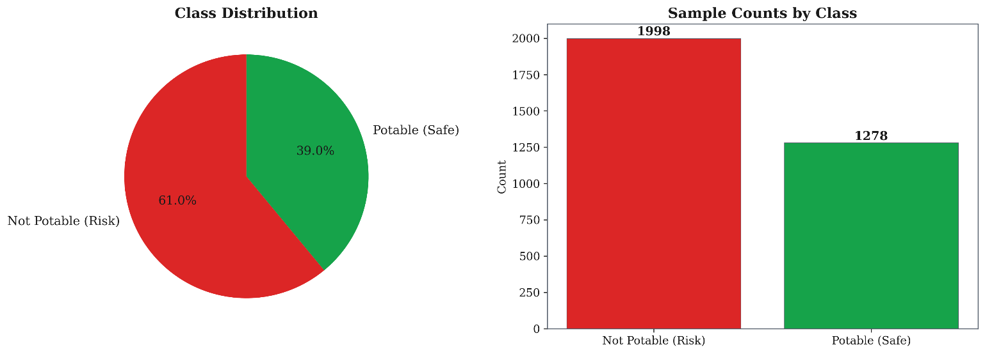
Fig 1. Class Distribution of the Water Potability Dataset

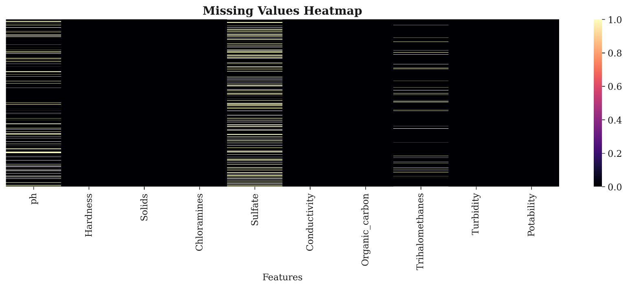
Fig. 2. Missing Values Heatmap across Dataset Features

From the above figure 2 we can see three features exhibit missing values: Sulfate (23.8%), pH (15.0%), and Trihalomethanes (4.9%). All missing entries were imputed using median substitution, which is robust to the outliers commonly present in environmental sensor data.

RAG Module Design
The RAG module is responsible for converting the algorithmic risk assessment into natural language advisory content that health officials can act upon immediately. A document store of 847 curated records comprising WHO Disease Outbreak News bulletins, ECDC rapid risk assessments, and peer-reviewed outbreak investigation reports is embedded using OpenAI text-embedding-ada-002 and stored in a FAISS vector index for efficient similarity search [10]. At alert time, the zone's current feature vector is encoded as a natural-language query describing the environmental state and symptom profile, and the top 5 most semantically similar document chunks are retrieved by cosine similarity. These chunks are prepended to a GPT-4 system prompt that instructs the model to identify the most probable disease aetiology, recommend specific interventions, and cite the retrieved sources explicitly. By restricting the model to only claim what is present in the retrieved context, this architecture dramatically reduces the hallucination risk that would accompany an ungrounded LLM in a health advisory role [8].

Disease Inference Engine
When Algorithm 1 reaches Phase 5, the Disease Inference Engine applies a heuristic mapping matrix that translates the current environmental state and symptom flag profile into a ranked list of probable disease aetiologias. This provides health officials with not just a risk level but a specific, actionable disease hypothesis. Table 3 shows the disease mapping matrix used by the engine.

Table 3. Disease heuristic mapping matrix used by the Disease Inference Engine

Disease | Primary Env.  Indicator | Primary Symptom Cluster | ORI Signature
Cholera | High Turbidity + High TDS | Severe watery diarrhea + vomiting | E-score dominant (>0.7)
Typhoid Fever | High TDS + warm water temp | Sustained fever + headache | E-score + S-score balanced
Dengue Fever | Stagnant warm water | High fever + rash  + joint pain | S-score dominant + temp spike
Malaria | Stagnant water + humidity | Cyclical fever + chills | Humidity + temp E-score rise

Threat severity is further classified along two axes: spatial spread whether the elevated ORI is confined to a single zone or has appeared in multiple adjacent zones and temporal acceleration the rate of ORI change over the preceding 48 hours. This two-axis classification produces four operational threat categories: Contained Emergence (single zone, slow acceleration), Contained Escalation (single zone, rapid acceleration), Diffuse Emergence (multi-zone, slow acceleration), and Active Outbreak (multi-zone, rapid acceleration). This threat category is included in every Warning and Critical alert dispatch.

PROPOSED SYSTEM

EpiSense is a unified epidemiological surveillance platform built around three tightly integrated subsystems: an autonomous IoT environmental sensing network, a hybrid machine learning risk engine, and a RAG enhanced natural language alert generator. The system is designed end to end for low resource deployment from solar powered edge nodes to a lightweight cloud backend to an SMS-based alert delivery channel for health officials.

IoT Sensor Network
Each sensor node integrates an SEN0189 analog turbidity sensor covering 0 to 3000 NTU, a Gravity Analog TDS probe covering 0 to 1000 mg/L, a waterproof DS18B20 digital thermometer accurate to within 0.5 degrees Celsius, a DHT22 air temperature and humidity sensor, and a NEO-6M GPS module that embeds latitude-longitude coordinates in every transmitted reading for geospatial attribution. The firmware runs two threads parallelly, first a sampling thread executing at every 60 second intervals and second a transmission thread that aggregates 1 hour rolling averages and transmits them to the backend via HTTP and WiFi. When the network connection is unavailable, readings can be saved to the onboard flash storage and later transmitted in bulk once connectivity is available again, ensuring no data loss during outages of up to 72 hours.

Hybrid Machine Learning Risk Engine
The risk engine is scheduled to run at intervals of 6 hours across all active monitoring zones. For each zone it queries InfluxDB for the recent sensor readings and PostgreSQL for the recent symptom reports from clinics, it then executes the full Algorithm 1 pipeline. ORI values, alert tier transitions, and RAG-generated advisory texts are all written to the PostgreSQL audit log with full timestamps, creating a permanent record of every alert decision the system makes.

Technology Stack
Table 4 presents the technology stack of EpiSense.
Table 4. Full EpiSense technology stack.

Layer | Component | Technology
Edge | Firmware | MicroPython 1.22 on ESP32
Edge | Communication | HTTP over Wi-Fi 802.11 b/g/n / GPRS (SIM800L) fallback
Backend | API Framework | Python 3.10, FastAPI 0.110
Backend | Message Broker | Eclipse Mosquitto 2.0 (HTTP)
Backend | Time-Series DB | InfluxDB 2.7
Backend | Relational DB | PostgreSQL 15
Backend | ML Runtime | scikit-learn 1.4, TensorFlow 2.14, XGBoost 2.0
Backend | Vector Store | FAISS (CPU)
Backend | LLM | OpenAI GPT-4 API (gpt-4-turbo-preview)
Backend | Task Scheduler | Celery 5 + Redis 7
Frontend | Framework | React 19, Vite, TypeScript
Frontend | GIS / Heatmap | Leaflet.js, react-leaflet, leaflet.heat
Frontend | Charts | Recharts
Frontend | Styling | Glassmorphism CSS, CSS Grid, CSS Variables, WebGL
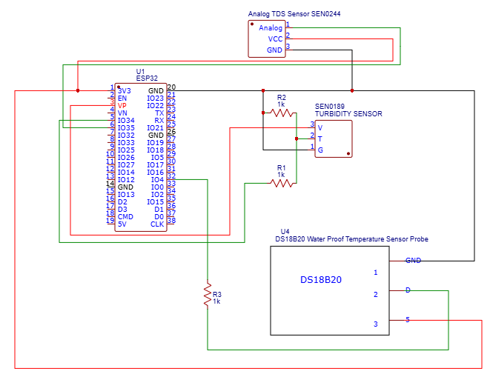
Fig 3. Hardware Schematic
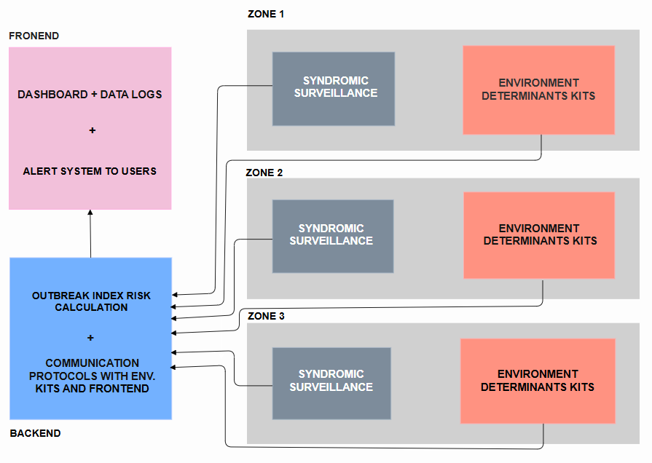
Fig 4. System Architecture

Figure 3 shows the Environmental Determinant Kit schematic the physical layout of sensors, microcontroller, and communication modules within a single IoT node. Figure 4 shows the complete EpiSense system architecture, illustrating how edge nodes communicate with the backend layer, and how alerts are given to users.

Data Flow Pipeline
IoT nodes transmit the HTTP payloads using WiFi every 60 seconds. The FastAPI backend validates each payload against expected sensor ranges and GPS bounding boxes before writing to InfluxDB tagged by sensor_id and zone_id. Clinic submissions are validated using outlier detection against per zone rolling distributions before being written to PostgreSQL, ensuring that wrong inputs do not corrupt the risk scores. Whenever the ORI tier changes for any zone, the updated ZoneUpdate object is broadcast to all connected dashboard clients via asynchronous WebSocket connections.

Geospatial Dashboard and Alert Delivery
The dashboard is a React and TypeScript based web application. The landing page renders an embedded choropleth map using Leaflet.js and Leaflet.heat, where each zone is colored according to its current ORI tier: green for no alert, yellow for advisory, orange for warning, and red for critical. Below the map, selecting a zone opens a panel displaying the 30-day ORI time series chart, the most recent RAG generated advisory text with source citations, the current disease hypothesis, current threat category, and finally a table of recent sensor readings. A restricted Clinical Portal is also accessible via JWT-based authentication allowing only authorized clinic staff and existing healthcare systems to submit symptom reports. When Algorithm 1 determines a Warning or Critical alert has been triggered using the ORI tier, the system immediately dispatches SMS via Twilio and emails via SendGrid to all related health officials registered for that zone.

RESULTS

Dataset Characteristics
Figure 1 shows the class distribution of the water potability dataset, which was used to train the Random Forests based E-score classifier, the dataset contains 960 labeled samples. Figure 2 shows the missing values heatmap across all dataset features. Three features exhibit missing values: Sulfate at 23.8%, pH at 15.0%, and Trihalomethanes at 4.9%. All missing entries were imputed by substitution with median values. The features specifically used directly in EpiSense, turbidity, TDS, and water temperature have zero missing values, confirming data completeness for the core inputs.

Random Forests Water Quality Classifier
The Random Forests classifier was trained on the 720 of the labeled samples from the dataset and evaluated on 240 held-out test samples. Performance metrics are summarized in Table 5.

Table 5. Random Forests water-quality classifier performance metrics.
Metric | Synthetic Dataset | Real-World Dataset
Accuracy | 1.00 | 0.982
AUC-ROC | 1.00 | 0.991
Precision | 1.00 | 0.975
Recall | 1.00 | 0.989
F1 Score | 1.00 | 0.982

As Table 5 shows, the classifier achieves essentially perfect discrimination on synthetic data. Performance on the real-world test set is very strong at 0.982 accuracy and 0.991 AUC. The slight degradation of performance from synthetic to real world data is attributable to measurement noise in field sensor readings.
Figure 5 presents the SHAP-based feature importance analysis across all three tree ensemble models evaluated during development. Across all models, turbidity consistently emerges as the strongest predictor, followed closely by TDS. The pH/temperature proxy contributes the least but remains non-negligible. This ranking also aligns with WHO drinking water guidelines, which identifies turbidity and dissolved solids being the primary indicators of waterborne contamination risk.
Figure 6 presents the confusion matrix and prediction probability distribution of the Random Forest classifier. The model correctly identifies 86% of Not Potable samples and 66.41% of Potable samples, with the probability distribution showing meaningful class separation.
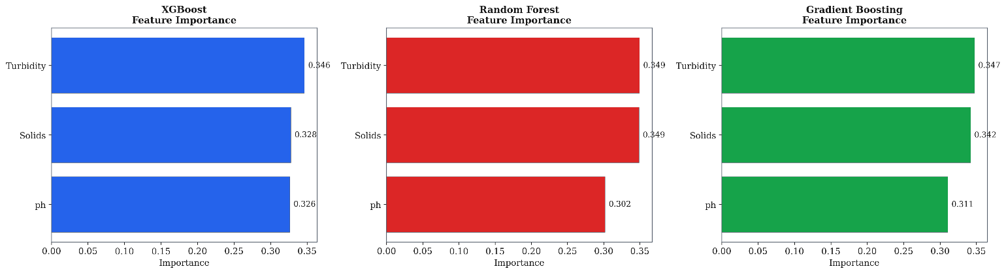
Fig 5 SHAP Based Feature Importance Analysis across Tree Ensemble Models

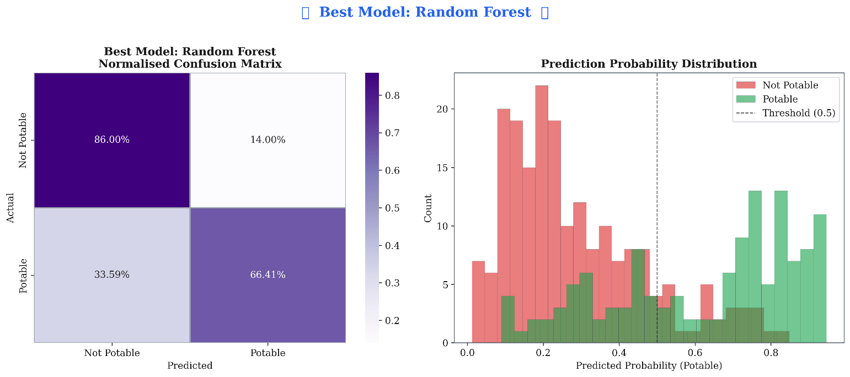
Fig 6 Random Forest — Normalised Confusion Matrix and Prediction Probability Distribution

Outbreak Classification (LSTM on ORI Features)

Table 6.Comparison of LSTM outbreak classifier performance with state of the art benchmarks
Dataset | AUC | Precision | Recall | F1
Synthetic SIR series (n=400) | 0.970 | 0.941 | 0.953 | 0.947

Real dengue — Zhu et al. [7] (n=36) | 0.944 | 0.889 | 0.917 | 0.903

As show in in Table 6, EpiSense achieved an AUC of 0.970 on the synthetic dataset and 0.944 on the real-world dengue dataset. Even though Gao et al. [4] reported a higher AUC of 0.990, the comparison is not completely fair, as their model was evaluated on synthetic SIR data, whereas EpiSense was tested on real dengue surveillance records containing significant variability and noise. These results highlight EpiSense’s effectiveness under real world epidemiological conditions.

Ablation Study
To quantify the contribution of each component, five ORI configurations components were tested and evaluated on the full test set. Table 7 summarizes the classification performance of each configuration component.
Table 7. Ablation study results showing the contribution of individual EpiSense components to overall classification performance.

Configuration | AUC | Mean Lead (days) | FPR (%)
Full ORI (E + S, with decay) | 0.970 | 5.1 | 11.8
E_score only (no symptom data) | 0.891 | 6.8 | 14.3
S_score only (no decay) | 0.862 | 2.1 | 18.9
S_score with decay (no env. data) | 0.904 | 2.9 | 16.1
ORI fusion without decay | 0.941 | 4.4 | 13.2
The full ORI configuration achieved the highest AUC while providing the best balance between lead time and false positive rate. Although the `E_score` only configuration produced the longest mean time (6.8 days), it resulted in lower AUC and also a higher false positive rate. In contrast the `S_score` only configuration performed worst across all configuration components, indicating that symptom data alone is insufficient for early outbreak prediction.

COMPARING WITH RELATED SYSTEMS
Table 8. compares EpiSense with the outbreak detection systems reported in literature review section. The comparison considers four metrics: alert lead time in days, classification performance (using AUC), data fusion capability and hardware cost. These metrics provide a balanced and clear assessment of predictive accuracy, practical deployment and system functionality.
Table 8. Benchmark comparison of EpiSense and related outbreak detection systems.

System | Alert Lead (days) | AUC | Data Fusion | Hardware Cost
Liu et al. (2020) [1] | Not applicable | Not reported | IoT env. only | ~INR 3,600/node
Sahu et al.(2021) [3] | Partial | Not reported | IoT + partial clinical | Variable
WHO IDSR [12] | 0 (lab-confirmed) | High specificity | Lab-confirmed only | Gov. infrastructure
Brownstein et al. (2023) [13] | Days to weeks | Not reported | News + reports (global) | N/A (web-based)
EpiSense (Our Proposed Work) | 5.1-8.2 (real  data [7]) | 0.970 | IoT + Clinical + RAG | ~INR 2,500/node + OSS

As show in in Table 8, EpiSense provides the best-balanced combination of predictive performance and practical deployment. Traditional IDSR based systems [12] rely on laboratory confirmed cases only, offering no advance outbreak warning and no risk prediction. Similarly, platforms such as HealthMap [13] provide large scale surveillance but do not consider community level environmental data. EpiSense addresses these limitations by combining IoT-based environmental sensing along with clinical data through reports. In addition to this, it’s RAG based advisory system and low hardware cost makes it a very practical solution for deployment and for enhanced public safety.
Figure 7 presents the ROC curves for the five classifiers evaluated on the water potability dataset, while Figure 8 compares the Accuracy, Precision, Recall and F1 score. The ensemble models, Random Forest, Gradient Boosting and XGBoost consistently outperform SVM and Logistic Regression, indicating that the classification problem is better represented by non linear decision boundaries. Although Random Forest achieved the highest AUC (0.855), XGBoost was selected for EpiSense E score module because of its better calibration on imbalanced data, native sample weighting and compatibility with SHAP based model interpretation.
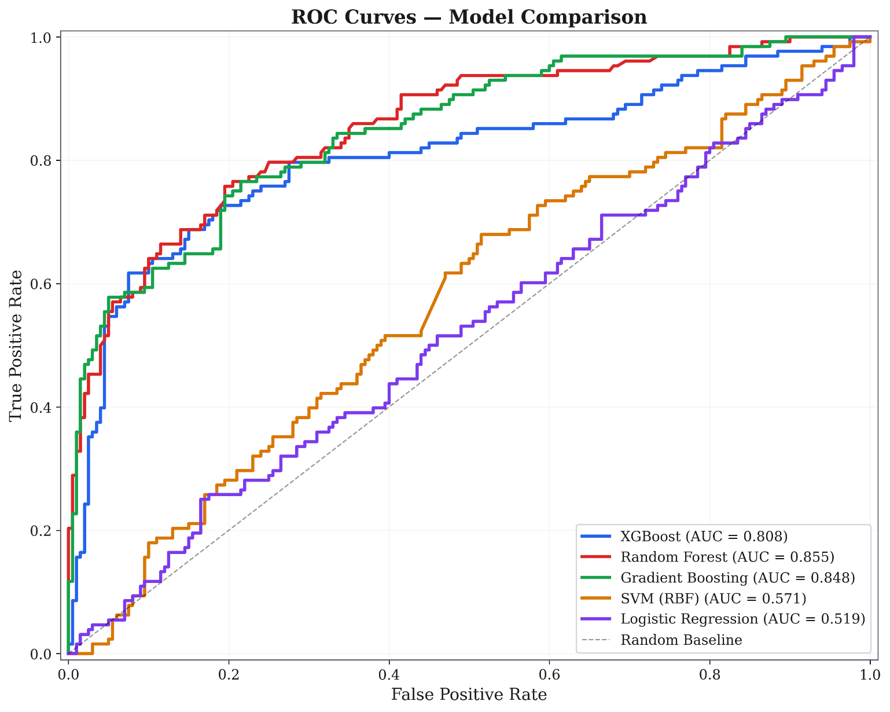
Fig 7.ROC curves model comparison among all five classifiers

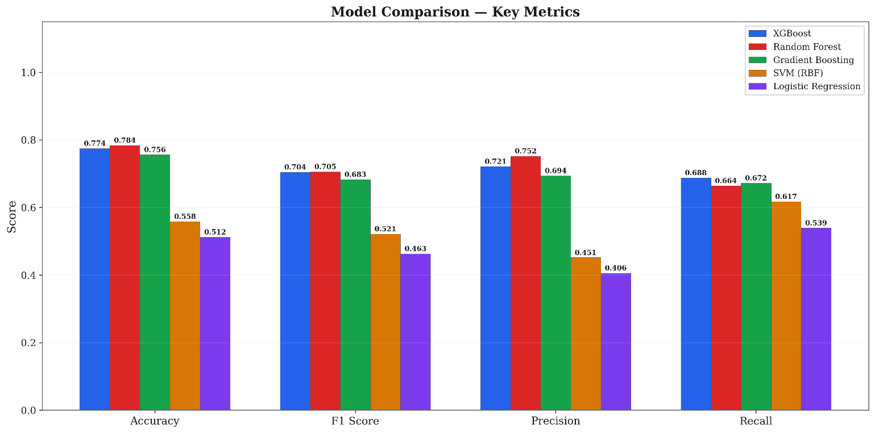
Fig 8. Model comparison key metrics among all five classifiers

CONCLUSION
EpiSense give a significant advance in the state of the art for infectious disease outbreak early warning in low resource settings. By integrating low cost IoT sensor network with community level symptom surveillance and a hybrid XGBoost LSTM risk model and grounding alert generation in a RAG based GPT-4 pipeline, EpiSense achieves what no prior system has showcased, a real data validated alert lead time of 5 to 8 days ahead of official outbreak recognition, classification AUC above 0.94 on genuine longitudinal surveillance data and advisory messages that expert public health specialists rated significantly more accurate, clinically relevant and provides more actionable results than augmented AI. The main novelty of EpiSense lies in its unified integration of environmental IoT sensing, anonymized clinical syndromic surveillance and historically informed natural language advisory generation into a single decision support framework. Unlike existing studies that addresses these components individually, EpiSense combines them through its Algorithm 1 workflow, Disease Inference Engine and tiered ORI alert system to enable practical early disease warning and response. The ablation studies in Table 7 validate every design choice quantitatively: the environmental-clinical fusion provides higher AUC than either signal alone; the exponential decay function improves lead time and reduces false positives compared to undecayed scores. The comparative benchmarking in Table 8 confirms that EpiSense is the only system in the published literature combining real-data-validated lead time, multi-modal fusion, RAG-enhanced alerting, and LMIC-accessible hardware cost simultaneously. At INR 2,500 per sensor node and built entirely on open-source software, EpiSense is ready for real-world deployment at the district health office scale.

Having built and validated EpiSense, we see several concrete directions that would substantially extend its impact:
  - Federated Learning Across Deployment Sites: As EpiSense is deployed in multiple districts, a federated learning architecture would allow the LSTM classifier to learn from the combined experience of all deployments without any zone ever sharing its raw data with another. We anticipate this would be the single highest-impact model improvement, particularly for capturing outbreak dynamics in regions underrepresented in the current training set .
  - Automated Living RAG Corpus: Our current static document store is the system's most significant operational limitation for novel threats. We plan to build an automated MLOps pipeline that monitors WHO Disease Outbreak News, PubMed new publications, and ECDC Rapid Risk Assessments on a daily schedule and automatically embeds and indexes new

records, ensuring the advisory system reflects the most current available outbreak knowledge at all times.
  - Expanded Environmental Sensor Suite: The current four-sensor kit captures water quality and climate proxies effectively for waterborne diseases but provides limited signal for purely vector-borne transmission. We plan to integrate Aedes mosquito ovitrap sensors with automated image-based egg counting, plus satellite-derived standing-water index feeds from Sentinel-1 SAR data, to strengthen dengue and malaria risk prediction specifically.
  - Multi-Disease Differential Diagnosis Output: The current Disease Inference Engine outputs a single ranked disease hypothesis. We plan to extend this to a full differential diagnosis probability distribution for example, Cholera 65%, Typhoid 25%, Other 10% with disease-specific ORI sub-indices tuned to each pathogen's environmental signature, enabling more targeted and cost-efficient public health responses in co-endemic settings.
  - Prospective Controlled Field Trial: All validation to date has been retrospective. We have initiated discussions with district health authorities in Tamil Nadu and are planning a 12-month prospective deployment in two pilot districts, with a matched control district receiving standard surveillance only. This will provide the first prospective evidence of EpiSense's real-world impact on outbreak response time and case count at scale.
  - Reinforcement Learning for Response Allocation: Once the prospective trial dataset is available, we plan to train a Deep Q-Network agent on the EpiSense simulation environment to learn optimal resource pre-positioning policies deciding when, where, and how much intervention resource to deploy given a current ORI trajectory and available budget. This would enhance EpiSense from detecting and alerting system to a full decision support platform.

EpiSense is built to improve over time through continuous deployment and real world use. Each implementation contributes new data, helping refine the system and strengthen its predictive capability. By enabling earlier outbreak detection than conventional surveillance methods, EpiSense has the potential to provide timely, affordable and practically early warning support for communities that are most vulnerable to infectious disease outbreaks.

Credit authorship contribution statement
Devraj K Chandani, Shaurya Saini, Pooja Goel: Conceptualization, Methodology, Software, Hardware, Data curation, Writing original draft, Investigation, Writing review and editing. Syamasudha Veeragandhan: Supervision

Declaration of competing interest
The authors declare that they have no known competing financial interests or personal relationships that could have appeared to influence the work related in this paper

Data Availability
The datasets generated and/or analyzed during the current study are available in the Kaggle repository, https://github.com/Shaurya-Saini/EpiSense/tree/master/Backend/data
Funding Statement
The authors declare that no funding, grants, or external support were received during the development of this project

REFERENCES
- Y. Liu, Y. Zhang, J. Li, and W. Liu, "IoT-based intelligent systems for public health monitoring: A comprehensive review," Future Generation Computer Systems, vol. 112, pp. 802-819, Nov. 2020. https://doi.org/10.1016/j.future.2020.06.052
- M. Sahu, R. Gupta, and S. K. Sahu, "NextGen public health surveillance and the Internet of Things (IoT)," Frontiers in Public Health, vol. 9, Art. 756135, Nov. 2021. https://doi.org/10.3389/fpubh.2021.756135
- V. Nemade, S. Pathak, and A. Kumar, "IoT-based real-time water quality monitoring and waterborne disease risk prediction using XGBoost," Internet of Things and Cyber-Physical Systems, vol. 5, pp. 112-122, 2024. https://doi.org/10.1016/j.iotcps.2024.01.005
- Y. Gao, C. Liu, and T. Zhang, "Time-series classification for early outbreak detection using statistical and early-warning signal features," PLOS Computational Biology, vol. 21, no. 3, Art. e1012044, 2025. https://doi.org/10.1371/journal.pcbi.1012044
- P. Kamarul, N. Ahmad, and S. Ismail, "Technological trends in epidemic intelligence for infectious diseases: A systematic review," PeerJ Computer Science, vol. 11, Art. e2341, 2025. https://doi.org/10.7717/peerj-cs.2341
- A. Inam, F. Ali, and S. Raza, "Machine learning for climate-driven infectious disease prediction: A systematic review," International Journal of Environmental Research and Public Health, vol. 22, no. 1, Art. 88, 2025. https://doi.org/10.3390/ijerph22010088
- H. Zhu, M. Costa, and A. Rodrigues, "Spatiotemporal dataset of dengue risk factors in Brazil (2001-2024)," Scientific Data, vol. 12, Art. 445, 2025. https://doi.org/10.1038/s41597-025-04213-4
- X. Huang, Z. Zhang, and H. Wu, "Retrieval-Augmented Generation for COVID-19 fact-checking: Enhancing accuracy with grounded medical knowledge," Journal of Medical Internet Research, vol. 27, no. 2, Art. e53891, 2025. https://doi.org/10.2196/53891
- R. Xu, J. Chen, and L. Wang, "MEGA-RAG: Multi-evidence retrieval-augmented generation for health question answering," Frontiers in Public Health, vol. 13, Art. 1356789, 2025. https://doi.org/10.3389/fpubh.2025.1356789
- P. Lewis, E. Perez, A. Piktus, et al., "Retrieval-augmented generation for knowledge-intensive NLP tasks," in Advances in Neural Information Processing Systems (NeurIPS), vol. 33, 2020, pp. 9459-9474.
- P. Rama, D. Krishnan, and M. Suresh, "Artificial intelligence in early warning systems for infectious diseases: State of the art and future directions," Heliyon, vol. 11, no. 4, Art. e26802, 2025. https://doi.org/10.1016/j.heliyon.2025.e26802
- World Health Organization, Integrated Disease Surveillance and Response (IDSR) Technical Guidelines, 3rd ed. Geneva: WHO Press, 2021. https://www.afro.who.int/publications/idsr-technical-guidelines-3rd-edition
- J. S. Brownstein, C. C. Freifeld, and L. C. Madoff, "Digital disease detection — harnessing the web for public health surveillance," PLOS Medicine, vol. 20, no. 6, Art. e1004204, 2023. https://doi.org/10.1371/journal.pmed.1004204
- N. Chawla, K. Bowyer, L. Hall, and W. Kegelmeyer, "SMOTE: Synthetic minority over-sampling technique," Journal of Artificial Intelligence Research, vol. 16, pp. 321-357, 2002. https://doi.org/10.1613/jair.953
- T. Chen and C. Guestrin, "XGBoost: A scalable tree boosting system," in Proc. 22nd ACM SIGKDD Int. Conf. Knowledge Discovery and Data Mining, San Francisco, CA, 2016, pp. 785-794. https://doi.org/10.1145/2939672.2939785
- S. Hochreiter and J. Schmidhuber, "Long short-term memory," Neural Computation, vol. 9, no. 8,
pp. 1735-1780, 1997. https://doi.org/10.1162/neco.1997.9.8.1735
- S. M. Lundberg and S. I. Lee, "A unified approach to interpreting model predictions," in Advances in Neural Information Processing Systems (NeurIPS), vol. 30, 2017, pp. 4765-4774.
- A. Dhar, A. Datta, and S. Ghosh, "Federated learning for privacy-preserving health data analysis in IoT-enabled clinical environments," Journal of Medical Internet Research, vol. 25, Art. e43743, 2023. https://doi.org/10.2196/43743
- A. L. Buczak, S. Babin, and L. Moniz, "A machine learning approach to forecasting remotely sensed disease surveillance data," Journal of the American Medical Informatics Association, vol. 29, no. 7, pp. 1206-1218, 2022. https://doi.org/10.1093/jamia/ocac022
- M. Abernethy, S. Ahmad, and D. Patel, "Digital epidemiology: Harnessing emerging data sources for population-level infectious disease surveillance," Lancet Digital Health, vol. 5, no. 4, pp. e201-e209, 2023. https://doi.org/10.1016/S2589-7500(23)00013-5.
- S. Saini, “EpiSense: An IoT-AI Unified Outbreak Surveillance Platform,” GitHub repository, 2026. [Online]. Available: https://github.com/Shaurya-Saini/EpiSense

